**Online Parking Reservation System**

**A Minor Project Synopsis Submitted to**



**Rajiv Gandhi Proudyogiki Vishwavidyalaya,**

**Bhopal**

**Towards Partial Fulfillment for the Award of**

**Bachelor of Engineering**

**(Information Technology)**

|  |  |  |  |
| --- | --- | --- | --- |
| **Under the Supervision of** | | | **Submitted By** |
| **Dr. Ronak Jain** | **Jitendra Vishwakrma(0827IT161045)** | | |
|  | **Kalpesh Patil (0827IT161046)** | | |
|  | **Kanit Khan(0827IT161047)** | | |



**Department of Information Technology**

**Acropolis Institute of Technology & Research, Indore**

**January-April 2019**

**EXAMINER APPROVAL**

The Project entitled “**Online Parking Reservation System**”

submitted by

|  |
| --- |
| **Jitendra Vishwakrma(0827IT161045),** |
| **Kalpesh Patil (0827IT161046),** |
| **Kanit Khan(0827IT161047)** |

has been examined and is hereby approved

towards partial fulfillment for the award of Bachelor of Engineering

degree in Information Technology discipline, for which it has been

submitted. It understood that by this approval the undersigned do not

necessarily endorse or approve any statement made, opinion expressed or

conclusion drawn therein, but approve the project only for the purpose for

which it has been submitted.

**(Internal Examiner) (External Examiner)**

**Date: Date:**

**GUIDE RECOMMENDATION**

This is to certify that the work embodied in this project entitled “**Online Parking Reservation System**” submitted by

|  |  |
| --- | --- |
| **Jitendra Vishwakrma(0827IT161045),** | Jitendra Vishwakrma(0827IT161045) |
| **Kalpesh Patil (0827IT161046),** | Kalpesh Patil (0827IT161046) |
| **Kanit Khan(0827IT161047)** | Kanit Khan(0827IT161047) |

is a satisfactory account of the bonafide work done under the supervision of

**Dr. Kamal Kumar Sethi**, is recommended towards partial fulfillment for

the award of the Bachelor of Engineering (Information Technology) degree

by Rajiv Gandhi Proudyogiki Vishwavidhyalaya, Bhopal.

**(Project Guide) (Project Coordinator)**

**STUDENTS UNDERTAKING**

This is to certify that project entitled “**Online Parking Reservation System**” has developed by us under the supervision of **Dr. Kamal**

**Kumar Sethi**. The whole responsibility of work done in this project is ours.

The sole intension of this work is only for practical learning and research.

We further declare that to the best of our knowledge, this report

does not contain any part of any work which has been submitted for the

award of any degree either in this University or in any other University /

Deemed University without proper citation and if the same work found

then we are liable for explanation to this.

|  |
| --- |
| **Jitendra Vishwakrma(0827IT161045)** |
| **Kalpesh Patil (0827IT161046)** |
| **Kanit Khan(0827IT161047)** |

**ACKNOWLEDGEMENT**

The project report is submitted to Acropolis institute of technology and research, Indore under R.G.P.V, Bhopal for the partial fulfillment of the degree of BE.

The success accomplished to this project would not be possible but for the timely help and guidance rendered by many people. I/We wish to express my/our sincere and heartfelt gratitude to all the personalities. First and foremost our sincere thanks to the Respected **Dr. Ronal Jain** for all his efforts and administration in educating us in his premier Institution.

We wish to express our sincere thanks to **Dr. Ronak Jain** for giving us this opportunity. We are also very thankful to **HOD, Information Technology**. **Dr. Kamal Sethi** , who has been a source of inspiration and has encouraged us in carrying out this project.

We are very thankful to our project guide, **Prof. Ronak Jain** for his great coordination and guidance for completing this project. We are thankful to RGPV class tutor for helping us in completing our project. We are thankful to our Department staffs who have given lot suggestions in carrying out our project. We are thankful to our Parents and Friends for helping us in completing our project.

**Jitendra Vishwakarma (0827IT161045)**

**Kalpesh Patil (0827IT161046)**

**Kanit Khan(0827IT161047)**

**“Where the vision is one year, cultivate flowers; Where the vision is ten years, cultivate trees; Where the vision is eternity, cultivate people.”**

**- Oriental Saying**

**CERTIFICATE OF ORIGINALITY**

This is to certify that this project synopsis entitled **“Online Parking Reservation System”** submitted to Acropolis institute of technology and research, Indore affiliated to R.G.P.V, Bhopal in partial fulfillment of the degree of **BE,** is an original work carried out by us. The matter embodied in this project is a genuine work done by us and has not been submitted whether to the University or any other University/Institution for the fulfillment of the requirement of any course of study.

Signature of the Student(s)

Date: ……………………

**Jitendra Vishwakarma (0827IT161045)**

**Kalpesh Patil (0827IT161046)**

**Kanit Khan(0827IT161047)**

IV

Table of Contents

Declaration..................................................................... 3

Approval......................................................................... 2

Guide Recommendation..................................................3

Student Undertaking........................................................4

Acknowledgement.......................................................... 5

Table of Contents........................................................... 6

Chapter One...................................................................10

1.0 Abstract……................................................................10

1.1 Introduction……………................................................10

1.3 Background of the study………………………………...11

1.4 Statement of the problem…........................................11

1.5 Team Organization……………………………………….11

1.5 Objectives of the Study...............................................12

1.6.1 Main Objectives:.......................................................12

1.6.2 Specific Objectives:...................................................13

1.6.3 Time Scope…………………………………………….13

1.7 Significance of Study....................................................14

1.8 Online Parking Reservation System……………………14

1.9 Observation……………………………………………….15

Chapter Two: .....................................................................16

2.1.1 System design and Implementation...........................16

2.1.1.1 System design ........................................................17

2.1.2 System Implementation............................................. 18

2.1.2.1 Date Storage…………………………………………..19

2.1.2.2 Interface and Authenticate User……………………..20

2.1.2.3 System Testing and Validation.................................21

2.1.2.4 Current Vehicle Parking Reservation system………22

2.1.2.5 Weakness of Current System………………………..23

2.1.2.6 System Requirement…………………………….……24

Chapter 3 ……………………………………………………19

3.1 Minimum Software Requirement…………………….. .19

3.1.1 System Requirement Specification...........................19

3.1.2 Role of SRS……………………………………………..20

3.1.2.1 Hardware Requirement………………………………20

3.1.2.2 Software Requirement……………………………….21

3.1.3 Overview OF front end…………………………………21

3.1.3.1 PHP……………………………………………………22

3.1.3.2 HTML………………………………………………….22

3.1.4 Overview of Back end………………………………….23.

3.1.4.1 MYSQL……………………………………………….23

Chapter 4 ………………………………………………………24

4.1 Requirements................................................................24

4.1.1 Functional Requirements............................................24

4.1.2 Non Functional requirements......................................24

Chapter 5………………………………………………………..25

5.1 Architectural design of System……………………………25

5.2 ER diagram…………………………………………………26

5.3 User Case Diagram………………………………………..27

5.4 Result of Implementation………………………………….28

5.5 result of Testing…………………………………………….29

5.6 Screenshot………………………………………………….30

5.7 Summary……………………………………………………35

5.8 Recommendations…………………………………………35

Chapter 6………………………………………………………..36

6.1 Source code………………………………………………..

6.2 Conclusion…………………………………………………60

6.3 References…………………………………………………61

**Chapter 1**

**1.0 Abstract**

The Online Parking Reservation System (OPRS) is a system that enables

customers/drivers to reserve a parking space. It also allows the customers/drivers to view the

parking status at kyebando people’s park. It was developed because the congestion and collision

of the vehicle, the system was developed for city mall located in Indore city.

Therefore the project aimed at solving such problems by designing a web based system that will

enable the customers/drivers to make a reservation of available parking space at people’s mall.

The requirements for the developed system were collected using observation and interviewing the

customer and staff member from the mall. The data from interviews was analyzed

using Microsoft Excel so as to come up with the functional, non- functional and system

requirements. These requirements were later used to design the system by creating data flow

diagrams and entity relationship diagrams. The designed system was implemented using different

development tools which include HTML for creating interfaces, CSS for styling wed pages

,JavaScript, and Jquery for dynamism in the web pages and as an input validation tool.XAMMP

was used to build the database and PHP used as a server side scripting language to connect the

user interfaces to the database. The system was tested by the researchers for errors.

**1.2 Introduction**

The parking place is very important all over the world especially in the cities of the countries.

Every day thousands of car drivers spend a lot of the time to find where to park. The result of

this situation is theft in urban areas, increasing traffic congestion and frustration of drivers. In order

to solve this problem, the implementation of Online Vehicle Park Reservation System in this city

for managing parking places is mandatory. It will allow the drivers to Reserve a parking place on

the Platform of city mall anytime, anywhere.

This chapter gives an overview of the background of the study, statement of the problems,

objectives of the study, research questions, scope of the study and significance of the study.

1.3 Background of the study

People’s Park Kyebando is located in Kampala district along Kampala –Gayaza rd and was

City mall is located in Madhya Pradesh district in 2019. it‘s located 1 mile from Kalwere round about, the mall

is constructed on 1 Acre of land (measurements 100ft-100ft) in Indore city, it provides

enough space for its well-wishing customers, It is equipped with high maximum security coupled

with an electric fence , four gun men from a well training security company and well trained bull

dogs have been also used to control trespassing within the People’s mall and with this maximum security, expenses like compensation of customers’ lost vehicles are brought down.

1.5 Team Organization

• Jitendra Vishwakrma :

Along with doing preliminary investigation and understanding the limitations of current system, I studied about the topic and its scope and surveyed various research papers related to the object detection and the technology that is to be used. I also worked on the implementation of tensorflow framework and the working of counting of objects in the project.

Worked on creating database for storing results in database.

Documentation is also a part of the work done by me in this project.

• Kanit Khan, Kalpesh Patil :

I investigated and found the right technology and studied in deep about it. For the implementation of the project , I collected the object data and trained the model for it. Implementation logic for the project objective and coding of internal functionalities is also done by me.

Also, worked on Back end design for storing results in database for maintaining logs.

1.5 Statement of the problem

The mall had challenges concerning its safety of data in the store since they

currently use paper based system, physical struggle for parking by drivers, wastage of time,

congestion and collision. There was also a problem of monitoring the profit made for the company

where by the company was losing money to its workers who receive the money (fraud).This system

majorly solved the congestion, collision and save time during parking activities.

security, expenses like compensation of customers’ lost vehicles are brought down.

1.6 Objectives of the Study

1.6.1 Main Objectives:

To enable drivers to locate and reserve a parking place online through accessing it on web

platform.

1.6.2 Specific Objectives:

• To establish possible solutions to improve on the current Vehicle Parking Reservation

To establish possible solutions to improve on the current Vehicle Parking Reservation

system

• To design and implement Online Vehicle Parking Reservation system

• To make a good research about People’s Park and gather all necessary information that

To design and implement Online Vehicle Parking Reservation system

To make a good research about People’s Park and gather all necessary information that

helped in designing the new parking reservation system.

1.6.3 Time Scope

The study was conducted for duration of four month from May-August 2019 from the stage of

analysis, data collection and system development, for the purpose of collecting righteous

information to enable me develop the system.

1.7 Significance of Study

• Due the increased transmission in information technology this makes the mall to change

from manual and local Vehicle Parking Reservation System to computerized and Online

Vehicle Parking Reservation system was used to make management, registration and

booking easier.

• The research has helped to minimize paperwork, errors made from the reservation office

like miss spelling the number plate, vehicle model, time wastage, delays and congestion

at the reservation office.

• The study was also useful to the researcher in the way that it helped him in putting the

acquired knowledge in Computer Science into practical perspective.

1.8 Online vehicle parking reservation system

According to Shem, S, S.Park and S.Hong (2006) online vehicle parking reservation system (OPRS)

is web-based used to reserve a park and data processing system. Drivers are no longer disturbed to

park their vehicle since the system generate the parking lot number on OPRS platform. A system

requirement of OPRS requires a currently supported version of Microsoft internet explorer or

Firefox. Access to confidential data in OPRS is secured using 12 bit secure socket layers (SSL) .

The way drivers locate and reserve parking places.

The Drivers especially those who may need get the parking spaces may find it impossible to access

it since there could be other vehicles blocking the way and yet they have to hurry to book for

parking spaces. This is because of using paper based which is unsecure and needs self-contact to

reserve for parking and it’s also time consuming, to design online vehicle parking reservation

system will provide better efficiency in locating parking space and paying for it.

According to Whapples (2005), online vehicle parking reservation will be also much faster, easier

on both sides (means clients and company). The time taken to serve a client is significantly reduced

since even the payment is done online .On company side this system will help their records (such

as clients’ details) to keep it in a secure way.

Improvement of the current car parking reservation system. From a literature studies, researcher found that Kianpisheh et al., (2012) proposed a new parking system called online vehicle park reservation system (0VRS), which assists the driver in finding a vacant place in a short time. ‘The system is designed for a two-level for booking Vehicle Park with 100 parking spaces. The most essential features of the OVPRS is to detect and present available parking spaces, provide payment facilities and various kinds of parking spaces (vacant

6 and reserved). After finding the preferable space the drivers will follow the procedures for booking if there is a vacant space. In addition, the driver should also notice the color, which determines the status of the place: green means the space is available and yellow means it has been reserved. The green color will automatically change to yellow when a driver booked the available space. This system will probably reduce time, cost and effort for finding a vacant place in PPK. They believe both car park operators and drivers will benefit from the system as parking spaces are easily acquired and parking space wastage is reduced.

The current systems used in parking places

Many parking places such as The PPK still use the manual or the paper based system for customers

‘parking reservation, data storage and payments.

According to Cegielski (2010), customers in many parking places come and then book for parking

of their vehicles, sometime congestion cause confusion and locating a vacant parking space can be

a big issue. Online vehicle parking reservation system will help solve this problem since the user

will have priory located and paid for the parking service .This will gives the people time to settle

down into the main activities of the day within the shortest time possible.

It would also relieve the workers who have offices in the parking places the hustle of trying to

locate a parking space every time they report working. This means their productivity would be

enhanced since they do not waste energy so early in the day.

ORS also requires cookies’ and scripting of java applets to be enabled

1.9 Observations

Observation as a method of data collection was used. In this aspect, the researcher used an

unstructured observation in order to identify physical social problem of PPK such as struggle to

park made by drivers, wastage of time, about data safety.

After gathering all the requirements from the stakeholders using all the above mentioned data

collection techniques, the gathered requirements were analyzed and validated to review

stakeholders’ information which was not always 100% accurate.

stakeholders’ information which was not always 100% accurate.

**2.1 Chapter 2**

**2.1.1 System design and Implementation**

2.1.1.1 System design

In the design phase the informational, functional, and network requirements identified during the initiation and planning phases will be converted into unified design specifications that will be used to script programs during the implementation phase. The design tools to be used were entity relationship diagram (was used in describing the relationships between entities), flow charts (was used to show the flow of events and how the processes are executed) and the following tools will be used: XAMMP to design a database, PHP and HTML to make interface, authenticate user and make a connection to a database, CSS to describe the presentation of a document and JAVASCRIPT to add interactivity, validation to the webpages.

**2.1.2 System Implementation**

2.1.2.1Data storage

We used XAMPP v3.2.1 which stands for Cross-Platform (X), Apache (A), MariaDB (M), PHP (P) and Perl (P). It is a simple, lightweight Apache distribution that makes it extremely easy for developers to create a local web server for testing and deployment purposes.it was used to manage record since is the one which contain the database of the system.

2.1.2.2 Interface and Authenticate user

The technology which was used to design Graphical User Interface is the HTML which is on client side programming to help the operation to be performed on client’s machine, Javascript was used for client-side validation .css was also used as style sheet language for describing the presentation of a document written in a markup language. In the system the server side programming which was used is PHP which is open source scripting language allows the operation to be performed on server, PHP code was embedded into HTML code. These are the explanation of the information which are on the table above which show us what will used to develop the web based application of Online Parking Reservation System.

2.1.2.3 System Testing and Validation

Researchers have carried out unit testing and also have carried out integration testing and full end to end system testing to ensure that few or no bugs found a place in the deployed application. Unit testing: This was done at the module level where basic components of the software were tested to verify its functionality. Integration testing: This was used to test the combined modules as a group to identify defects in the interfaces between integrated components. System testing: The complete integrated system was tested to verify whether all components work efficiently and effectively as a whole.

2.1.2.4 Current Vehicle Parking Reservation System

Kyebando peoples’ park is a private parking place. The Customers who need parking places come

The city mall is a private parking place. The Customers who need parking places come at the office and they book parking space for their vehicles, the process is file based where a

customer pays cash at the receptionist then a receipt is given to the customer to confirm that he/she

paid for the parking place.

2.1.2.5 Weaknesses of the Current System

A reasercher during his research about existing system he established different information from

various stake holders such us drivers and staff members, which identified the following weakness:

• Too much time and papers were wasted due to the fact that clients go and book physically

at the receptionist.

2.1.2.6 System Requirements

For the application to run on computer, the device is expected to meet the following system requirements. The system requirements were categorized into hardware and software requirements as shown in the tables 4.1 and 4.2 Table 1: Minimum Hardware Requirements Hardware Minimum Requirement Reason Processor speed 1.6GHZ Accommodate most PCs Memory of user PC 512MB RAM Relatively fast Disk Space of user PC 5GB Adequate Storage capacity Memory of server Pc 8GB Fast Bandwidth(network connection) 15Mbps Relatively Good Disk space of server 200GB Adequate Storage for database and application A fast processor is required because there is need to handle large amounts of data queries. 8 GB memory is required on the server for faster performance because it runs many processes simultaneously, while the memory in the computer should be relatively fast so as to run the processes required. 200 GB storage capacity in the server‘s hard disk is necessary for storage of huge amounts of data while the disk space in a user computer should be modest enough. Good network connection is vital because the application is majorly internet based and there is need for faster communication and retrieval of information.

Chapter 3

3.1 Minimum Software Requirements

3.1.1 System Requirement Specification (SRS)

Software Requirement specifications (SRS) is the starting point of the software developing activity. As system grew more complex it became evident that the goal of the entire system cannot be easier comprehended. Hence the need for the requirement phase arose. The software project is initiated by the client needs. The SRS is the means of translating the ideas of the minds of clients (the input) into a formal document (the output of the requirement phase.)

3.1.2 Role of SRS:

The purpose of the Software Requirement Specification is to reduce the communication gap between the clients and the developers. Software Requirement Specification is the medium through which the client and user needs are accurately specified. It forms the basis of software development. A good SRS should satisfy all the parties involved in the system Requirement Specifications: The focus is on specifying what has been found giving analysis such as representation, specification languages and tools and checking the specifications are addressed during this activity. The Requirement phase terminates with the production of the validate SRS document. Producing the SRS document is the basic goal of this phase.

3.1.2.1 Hardware Requirements:

• i3 Processor

• 2 GB Ram

• 50 GB Hard disk

3.1.2.2 Software Requirements:

• Operating System: Windows 8.1 or above

• Front End: PHP and HTML

• Back End: MySQL

3.1.3 Overview of the Front end:

3.1.3.1 PHP

PHP (recursive acronym for PHP: Hypertext Preprocessor) is a widely- used open source general-purpose scripting language that is especially suited for web development and can be embedded into HTML.PHP is a server-side scripting language designed primarily for web development but it is also used as a general-purpose programming language. PHP code may be embedded into HTML code, or it can be used in combination with various web template systems, web content management systems and web frameworks. PHP code is usually processed by a PHP interpreter implemented as a module in the web server or as a Common Gateway Interface (CGI) executable. The web server combines the results of the interpreted and executed PHP code, which may be any type of data, including images, with the generated web page. PHP code may also be executed with a command-line interface (CLI) and can be used to implement standalone graphical applications. The standard PHP interpreter, powered by the Zend Engine, is free software released under the PHP License. PHP has been widely ported and can be deployed on most web servers on almost every operating system and platform, free of charge.

The PHP language evolved without a written formal specification or standard until 2014, leaving the canonical PHP interpreter as Ade facto standard. Since 2014 work has gone on to create a formal PHP specification. The fact that PHP lacked an original overall design but instead developed organically has led to inconsistent naming of functions and inconsistent ordering of their parameters.]In some cases, the function names were chosen to match the lower-level libraries which PHP was "wrapping", while in some very early versions of PHP the length of the function names was used internally as a hash function, so names were chosen to improve the distribution of hash values.

3.1.3.2 HyperText Markup Language (HTML)

Hyper Text Markup language is the standard markup language for creating web pages and web applications. With Cascading Style Sheets (CSS), and JavaScript, it forms a triad of cornerstone technologies for the World Wide Web. HTML elements are the building blocks of HTML pages. With HTML constructs, images and other objects, such as interactive forms may be embedded into the rendered page. It provides a means to create structured documents by denoting structural semantics for text such as headings, paragraphs, lists, links, quotes and other items. HTML can embed programs written in a scripting language such as JavaScript which affect the behavior and content of web pages. Instead of lots of commands to output HTML (as seen in C or Perl), PHP pages contain HTML with embedded code. The PHP code is enclosed in special start and end processing instruction <? php and ?> that allow you to jump into and out of "PHP mode". What distinguishes PHP from something like client-side JavaScript is that the code is executed on the server, generating HTML which is then sent to the client. The client would receive the result of running that script, but would not know what the underlying code was. The best thing in using PHP are that it is extremely simple for a newcomer, but offers many advanced features for a professional programmer. Although PHP’s development is focused on server-side scripting, we can do much more with it.

• Hypertext refers to the way in which Web pages (HTML documents) are linked together. Thus the link available on a webpage are called Hypertext.

• As its name suggests, HTML is a Markup Language which means you use HTML to simply "mark up" a text document with tags that tell a Web browser how to structure it to display.

Originally, HTML was developed with the intent of defining the structure of documents like headings, paragraphs, lists, and so forth to facilitate the sharing of scientific information between researchers.

Now, HTML is being widely used to format web pages with the help of different tags available in HTML language.

**3.1.4 Overview of the Back end:**

3.1.4.1 MYSQL

MySQL is an open-source relational database management system (RDBMS). Its name is a combination of "My", the name of co-founder Michael Widenius’s daughter, and "SQL", the abbreviation for Structured Query Language. The MySQL development project has made its source code available under the terms of the GNU General Public License, as well as under a variety of proprietary agreements. MySQL was owned and sponsored by a single for-profit firm, the Swedish company MySQL AB, now owned by Oracle Corporation. For proprietary use, several paid editions are available, and offer additional functionality. MySQL is a central component of the LAMP open-source web application software stack.

The MySQL server software itself and the client libraries use dual-licensing distribution. They are offered under GPL version 2, beginning from 28 June 2000 (which in 2009 has been extended with a FLOSS License Exception) or to use a proprietary license.

Support can be obtained from the official manual. Free support additionally is available in different IRC channels and forums. Oracle offers paid support via its MySQL Enterprise products. They differ in the scope of services and in price. Additionally, a number of third party organizations exist to provide support and services, including MariaDBand Percona.

MySQL has received positive reviews, and reviewers noticed it "performs extremely well in the average case". And that the "developer interfaces are there, and the documentation (not to mention feedback in the real world via Web sites and the like) is very, very good".] It has also been tested to be a "fast, stable and true multi-user, multi-threaded sql database server".

**Chapter 4**

**4.1 Requirements**

**4.1.1 Functional Requirements**

1. The web application displays the availability of parking lot

2.The web application enables employees to set the reaching date and time for the car also the departure date and time.

3.The web application enables employees to cancel a parking place.

4.The web application enables drivers to book parking place.

**4.1.2 Non Functional requirements**

1. The designed system should have little or no down time. It should always be up and running.

2. The system should have a fast response time. System should not take more than 30 seconds minus loading

3. The system should be secure. User should fill in his/her email address and password so as to be authenticated to the system.

4. The system Should allow the customer to park without making a reservation.

5. The system should be scalable. Even with an increasing number of users, system should be able to perform effectively.

6. The system should be user friendly with ability to show users where they are in the system and guide them on some processes through programmed controls.

7. The system should be reliable. In case of system failure, the system should be

able to recover quickly and continue working normally

**Chapter 5**

**5.1 Architectural Design of the System**

The architectural design of the system shows how the architecture of OVPRS. The architecture of the system was based on the Ntier architecture model, where application is split into different layers. OVPRS is composed of different subsystems which when combined all together form the whole architecture of the system. Data storage occurs in the database which runs MySQL as the database engine. The topmost level of the web application is the presentation layer which displays information such as browsing parking lot, client, system user login, booking, etc. It communicates with other layers by which it puts out the results to the browser/client tier and all other tiers in the network. The Business Access Layer Project is responsible for all the business logic of the application by performing detailed processing, it interfaces the Data Access Layer and the presentation Layer. The Data Access Layer subsystem is responsible for accessing the database for data retrieval and insertion.

**5.2 Entity Relationship Diagram**

Entity Relationship Diagram (ERD), a database design tool that provides graphical representation of database tables, their columns and inter-relationships. This ERD provided a sufficient information for database administrator when I was developing and maintaining database

|  |  |
| --- | --- |
|  | User_zone_data |
|  | Status |
|  | model |
|  | Vehicle |
|  | Street |
|  | Plot |
| pk | plateno |
|  | Account |
|  | charge |
|  | Date_start |
|  | Date_end |

Reserve

|  |  |
| --- | --- |
|  | USERS |
| Pk | User_id |
|  | Fname |
|  | Email |
|  | Psw |
|  | P_booked |

Send

|  |  |
| --- | --- |
|  | Messages |
| Pk | Index |
|  | Fname |
|  | Email |
|  | Password |
|  | Message |

5.3 User Case Diagram

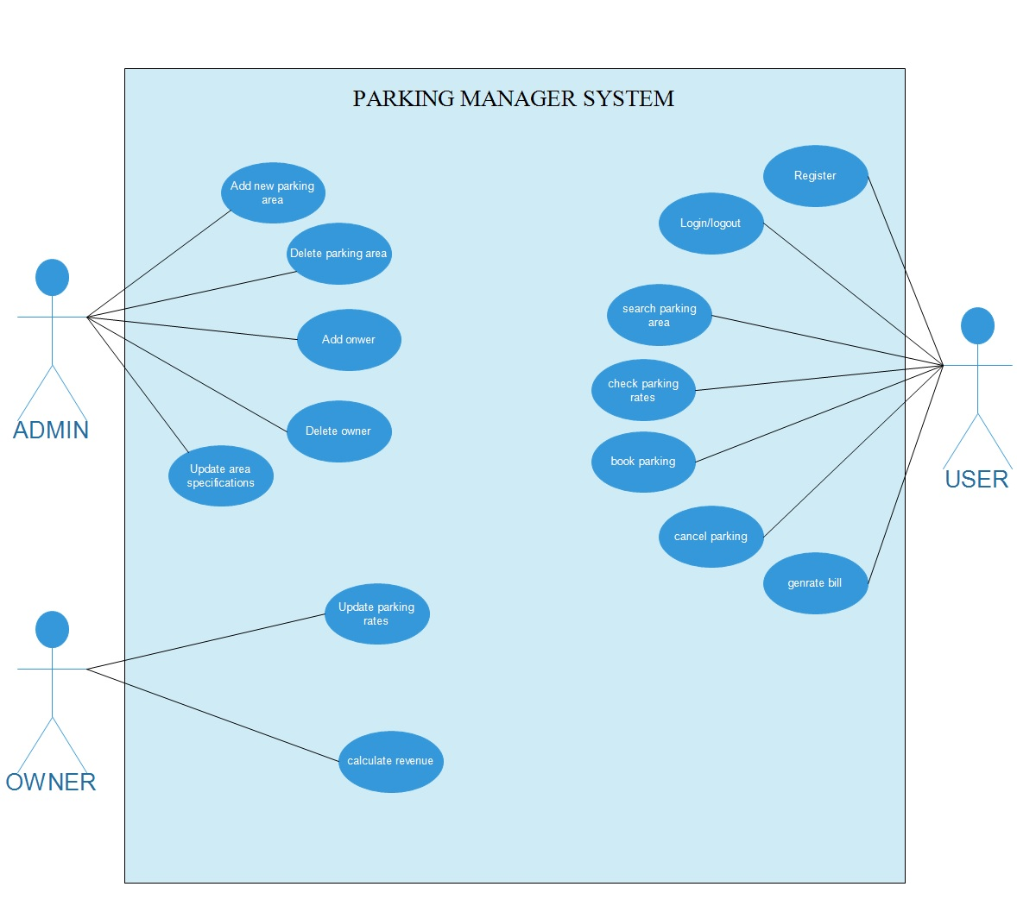

**5.4** **Results of Implementation**

The Researcher found out that it should have web interface where User of the system (Clients/Employees /system admin) can logon and register, interface where clients Can reserve a parking, can view parking status. Interface where The employee can book a parking for the client, can cancel a booking, can update and also can delete the client .system admin can manage all users of the system such us employee and Clients .manage the parking lot.

**5.5Results of Testing**

Cross browser testing was done by the researcher to ensure that the web application looks the same in major browsers that is Google chrome, Mozilla Firefox, Opera and Internet explorer. The web project is consistent (looks exactly the same) in Google chrome, Mozilla Firefox and Opera but the looks vary slightly in internet explorer.

**5.6 Screenshot**

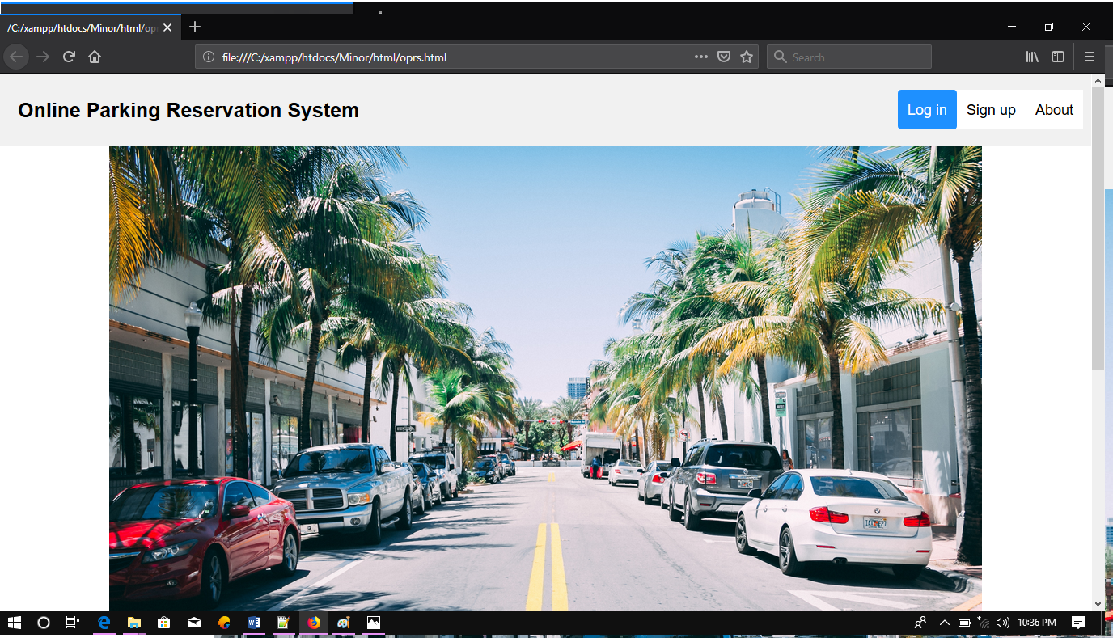

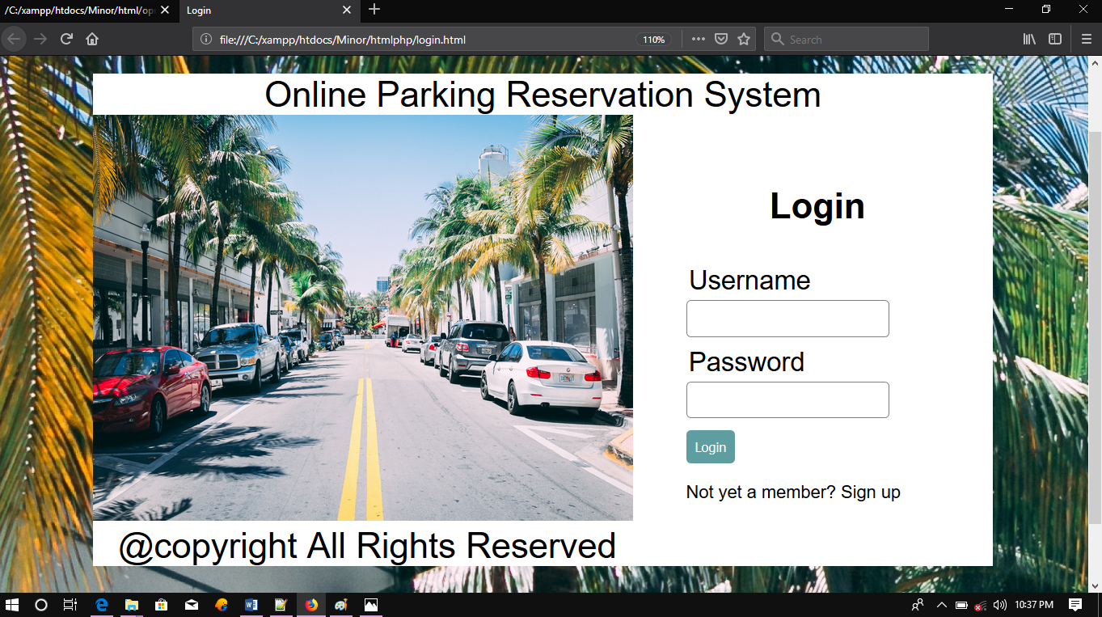

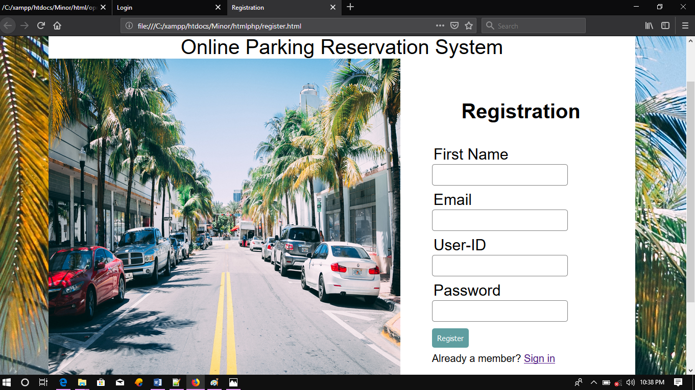

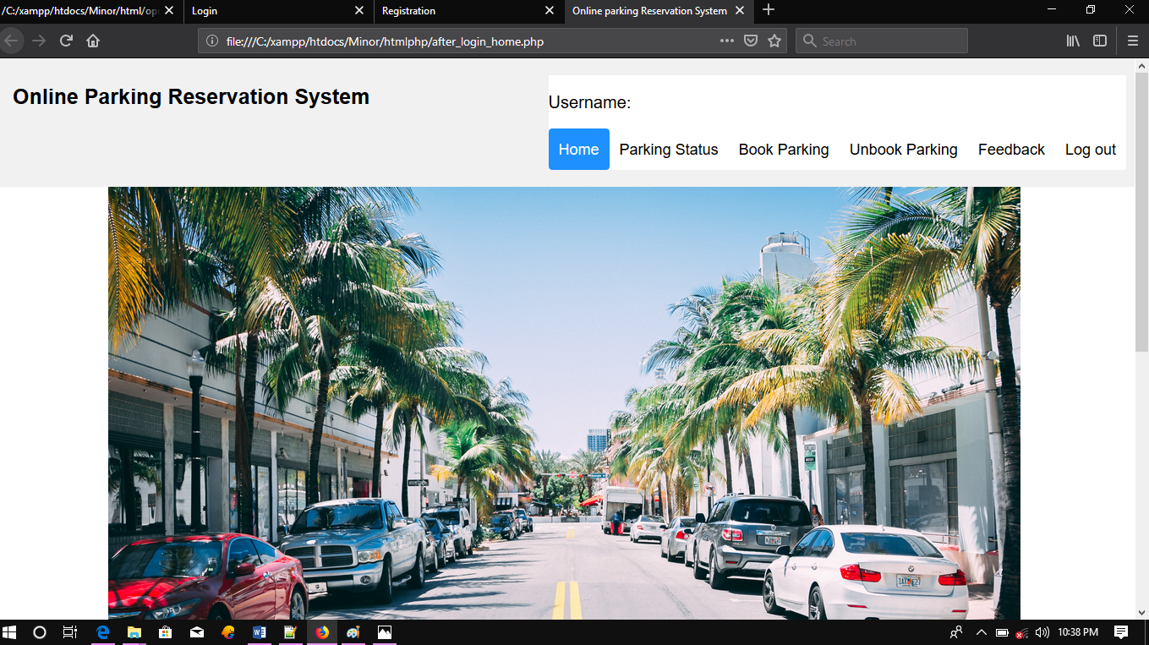

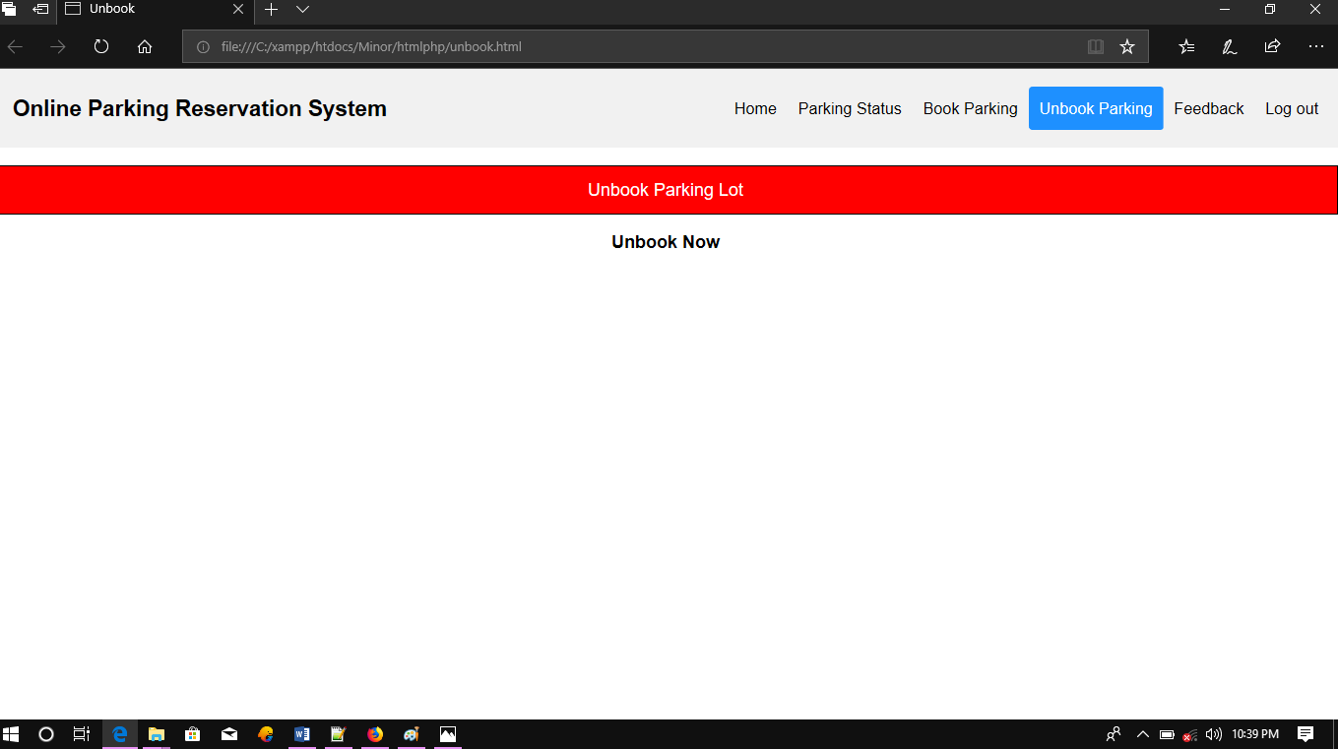

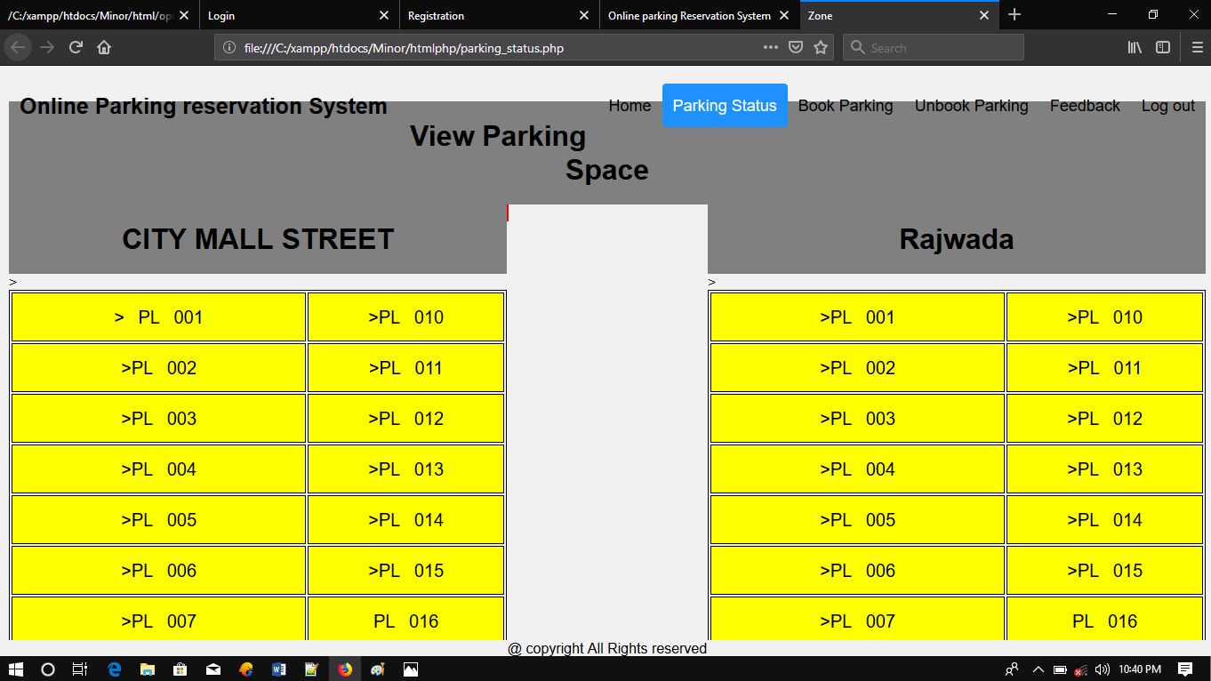

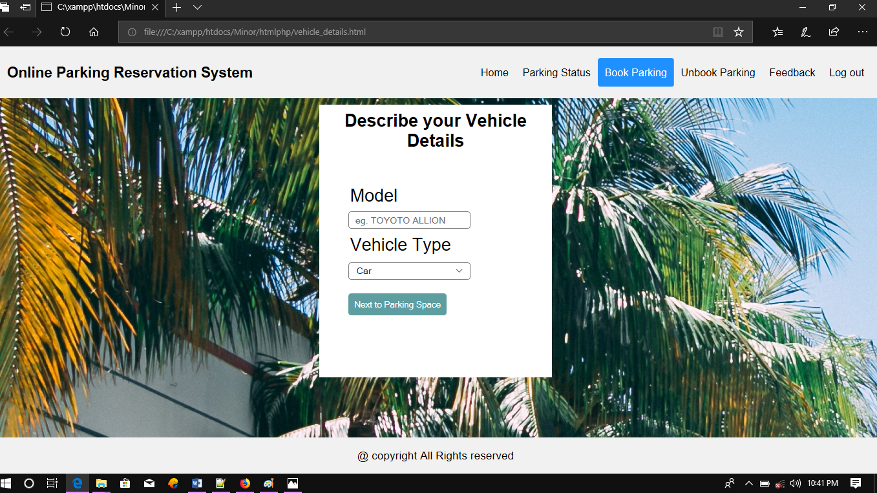

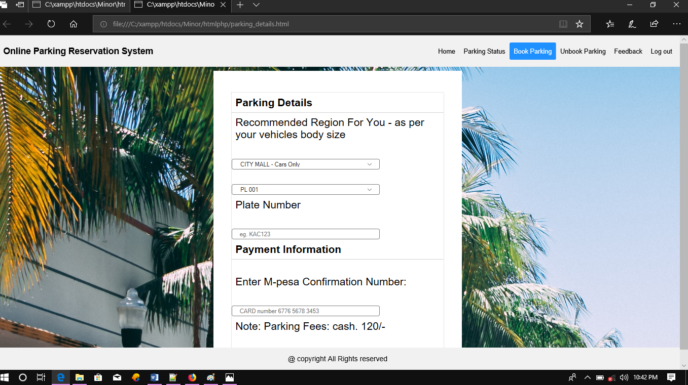

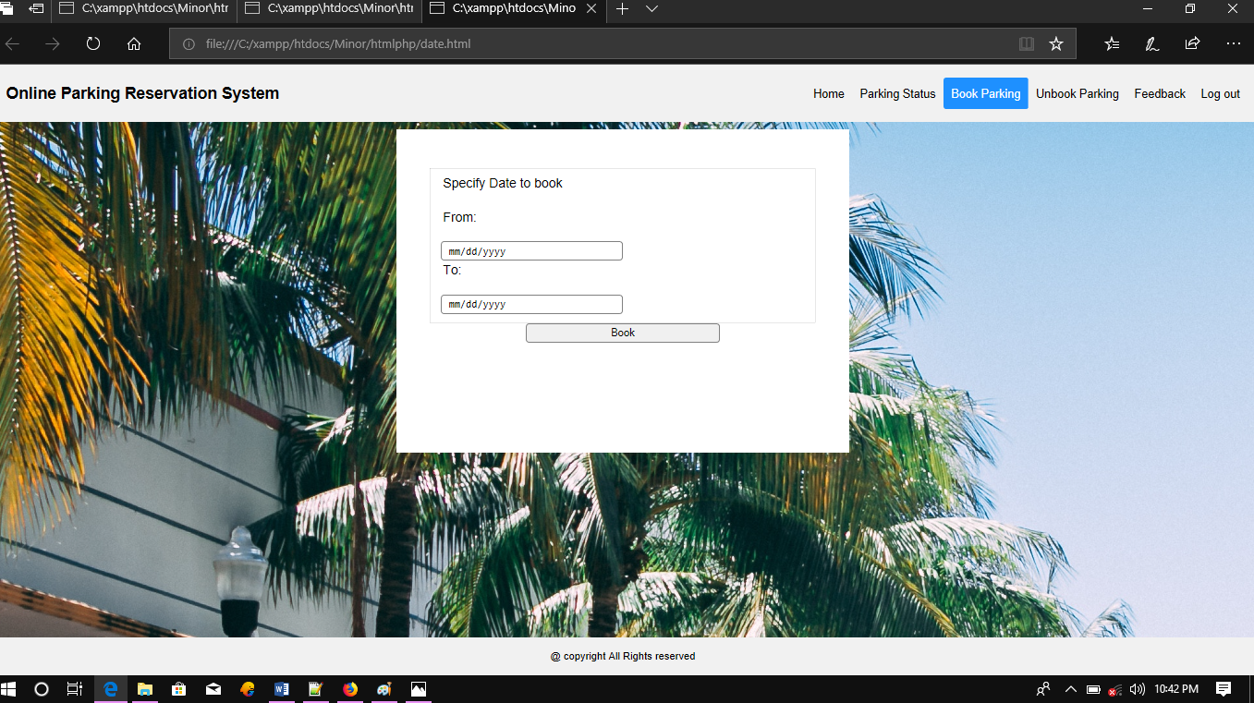

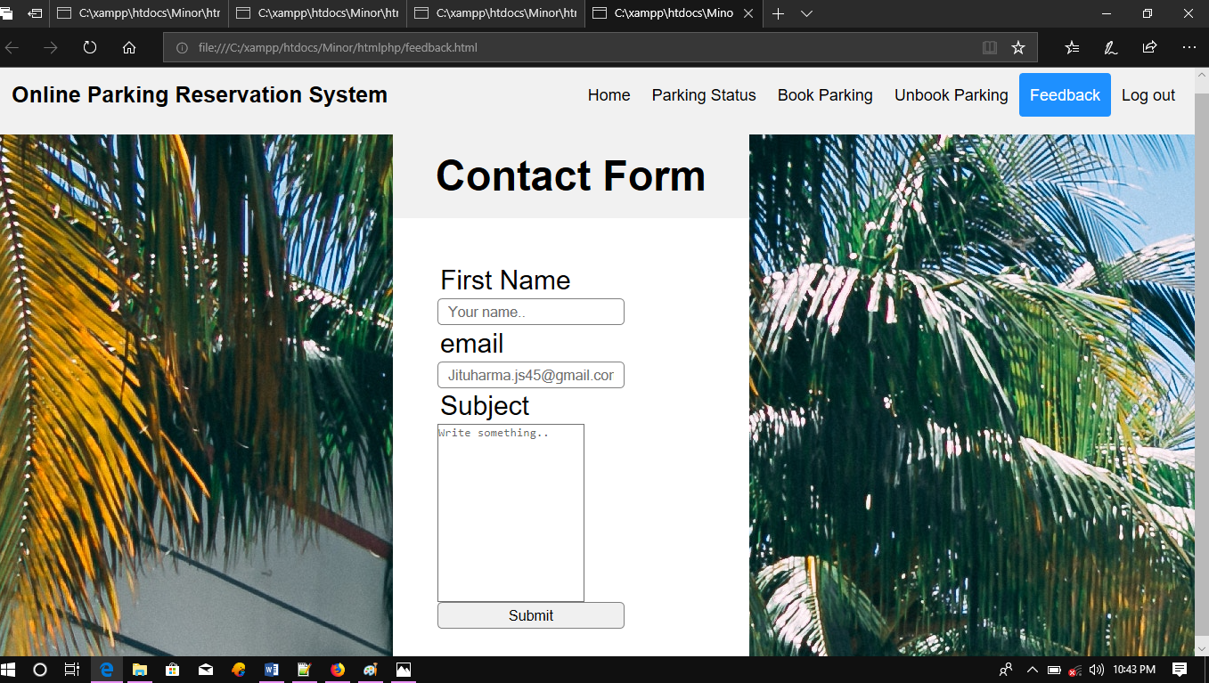

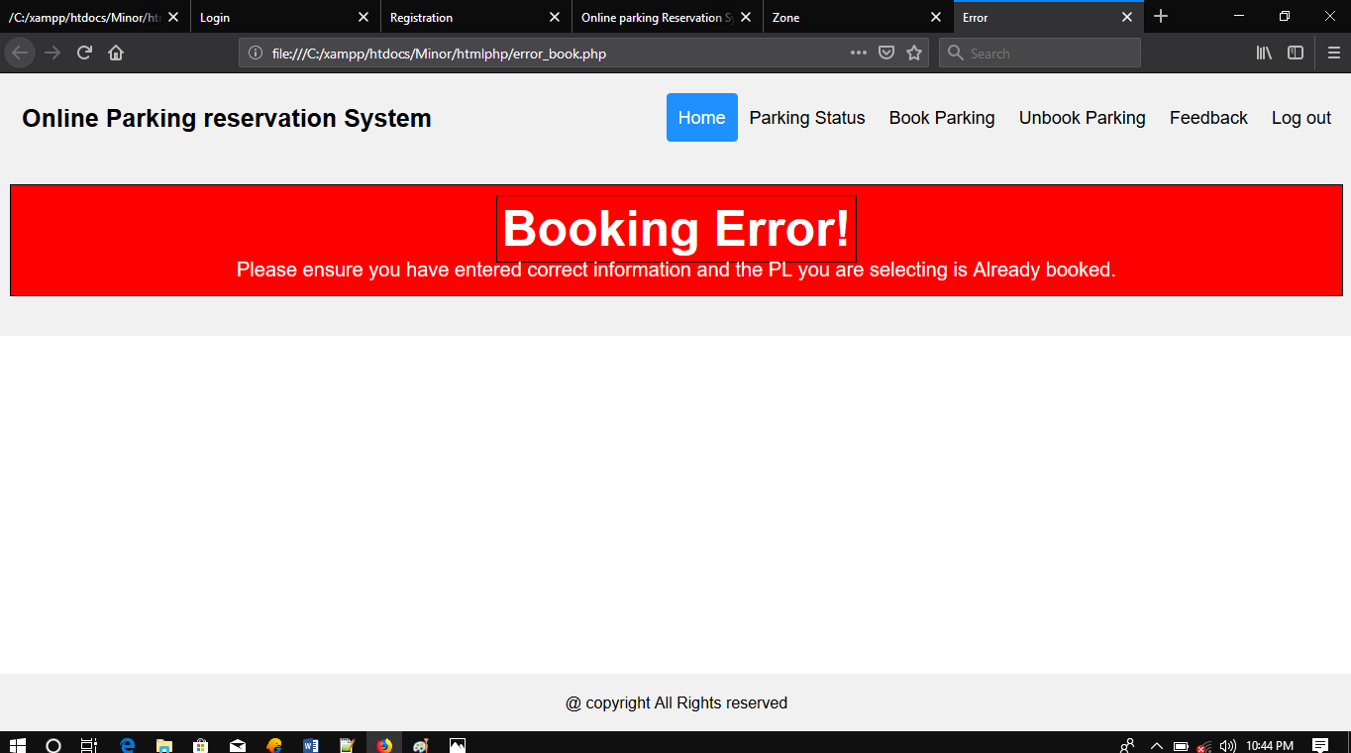

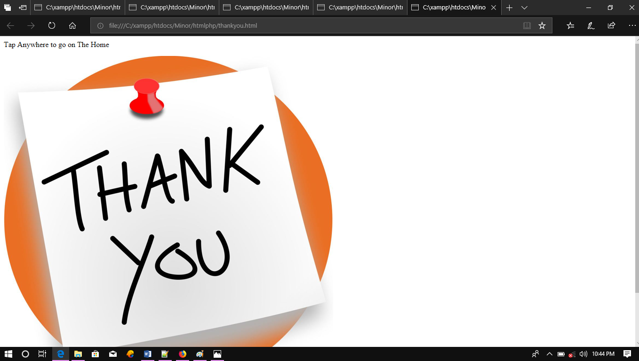

5.7 Summary

This project was aimed to Improve on the current Vehicle Parking Reservation systems by creating Online vehicle reservation system which enables the client/driver to book parking space online The existing vehicle parking reservation system was file based where customer pays cash at the receptionist then a receipt is given to the customer .this process was tiresome at kyebando people’s park. OVPRS enables drivers to locate and reserve a parking place online through accessing it on web platform where client login then she/he start process of booking a parking.

5.8 Recommendations

¬ Researcher recommend that the system be used by other parking companies because the

researcher believes that the system can effectively and efficiently display the parking lot

available, can allow clients, employee to reserve a free parking lot available.

¬ Researcher recommend that more research should be done such that the vehicles detail

should able to be scanned during entering in the parking place.

¬ More research should also be done to extend this project to include tracking vehicle by

using cctv camera for the purpose of maintaining the security.

¬ The Researcher recommend that through making the web application more responsive the

client will be able to reserve the parking lot on mobile devices easier.

**Chapter 6**

6.0 Source code::

<!DOCTYPE html>

<html>

<head>

<link rel="stylesheet" href="../css/oprs.css"/>

<meta name="viewport" content="width=device-width, initial-scale=1">

<style>

body {

margin: 0;

font-family: Arial, Helvetica, sans-serif;

}

.header {

overflow: hidden;

background-color: #f1f1f1;

padding: 20px 10px;

}

.header a {

float: left;

color: black;

text-align: center;

padding: 12px;

text-decoration: none;

font-size: 18px;

line-height: 25px;

border-radius: 4px;

}

.header a.logo {

font-size: 25px;

font-weight: bold;

}

.header a:hover {

background-color: #ddd;

color: black;

}

.header a.active {

background-color: dodgerblue;

color: white;

}

.header-right {

float: right;

}

</style>

</head>

<body>

<div class="header">

<a href="#default" class="logo">Online Parking Reservation System </a>

<div class="header-right">

<a class="active" href="../htmlphp/login.html">Log in </a>

<a href="../htmlphp/register.html">Sign up</a>

<a href="#about">About</a>

</div>

</div>

<div>

<img class="center" src="../images/bg.jpg" alt=""/></div>

</br>

<table align="center">

<tr>

<td>

<ul>

<li ><h3 >Online Parking reservation System</h3></li>

<li><p> It overcomes the problem of finding </p></li>

<li><p>a parking space in universities/institute areas</p></li>

<li><p> that unnecessary consumes time</p></li>

</ul>

</td>

<td>

<ul >

<li ><h3 >UseFull Links</h3></li>

<li><a href="feedback.html" >Contact Us</a> </li></br>

<li><a href="home.php">Home</a></li></br>

</ul>

</td>

<td>

<ul >

<li ><h3 >Address</h3></li>

<li><p>RGPV university</p> </li>

<li><p>bhopal(m.p.)</p></li>

</ul>

</td>

</tr>

</table>

<footer class="footer">

<h2>

&copy; copyright 2019 - 2020 All Rights Reserved</br>Terms & Conditions</br><a color="blue" href="OnlineParkingReservationSystem.html"> Online Vehicle Parking ReservationSystem</a>

</h2>

</footer>

</body>

</html>

<!DOCTYPE html>

<html>

<head>

<title>Success</title>

<style>

* {box-sizing: border-box;}

.div_1

{

height:100px;

width:200px;

color: black;

background: white;

text-align: center;

font-family:arial;

font-size:20px;

padding-top:230px;

margin: 0px auto 0px;

}

body {

margin: 0;

font-family: Arial, Helvetica, sans-serif;

}

.header {

overflow: hidden;

position:fixed;

left:0;

right:0;

top:0;

background-color: #f1f1f1;

padding: 20px 10px;

}

.footer {

overflow: hidden;

position:fixed;

left:0;

right:0;

text-align:center;

bottom:0;

background-color: #f1f1f1;

padding: 20px 10px;

}

.header a {

float: left;

color: black;

text-align: center;

padding: 12px;

text-decoration: none;

font-size: 18px;

line-height: 25px;

border-radius: 4px;

}

.header a.logo {

font-size: 25px;

font-weight: bold;

}

.header a:hover {

background-color: #ddd;

color: black;

}

.header a.active {

background-color: dodgerblue;

color: white;

}

.header-right {

float: right;

}

</style>

</head>

<body background="../images/bg.jpg"

>

<div class="header">

-

line-height: 25px;

border-radius: 4px;

}

.header a.logo {

font-size: 25px;

font-weight: bold;

}

.header a:hover {

background-color: #ddd;

color: black;

}

.header a.active {

background-color: dodgerblue;

color: white;

}

.header-right {

float: right;

}

</style>

</head>

<body>

<div class="header">

<a href="#default" class="logo">Online Parking reservation System</a>

<div class="header-right">

<a href="after_login_home.php">Home </a>

<a class="active" href="parking_status.php">Parking Status</a>

<a href="vehicle_details.html">Book Parking</a>

<a href="unbook.html">Unbook Parking</a>

<a href="feedback.html">Feedback</a>

<a href="php_logout.php">Log out</a>

</div>

<?php

session_start();

$connection = mysqli_connect('localhost', 'root', '','user_data');

$var = isset($_SESSION["to"]);

$date = str_replace('/', '.', $var);

echo date('Y.m.d', strtotime($date));

?>

</p>

<h1 >View Parking Space</h1>

<div class="inline">

<div class="left">

<h1>CITY MALL STREET </h1>

<table>

<?php $street ="CITY MALL"; ?>

<tr>

<td

<?php

$sql="SELECT * FROM user_zone_data WHERE street='$street' and plot='PL 001' and status='RESERVED' ";

$result=mysqli_query($connection,$sql);

$count=mysqli_num_rows($result);

if($count==1){

echo "style=\"background: red;\" ";}

?>>

PL 001

</td>

<td <?php

$sql="SELECT * FROM user_zone_data WHERE street='$street' and plot='PL 010' and status='RESERVED'";

$result=mysqli_query($connection,$sql);

$count=mysqli_num_rows($result);

if($count==1){

echo "style=\"background: red;\"";}

?>>PL 010</td>

</tr>

<tr>

<td

<?php

$sql="SELECT * FROM user_zone_data WHERE street='$street' and plot='PL 002' and status='RESERVED'";

$result=mysqli_query($connection,$sql);

$count=mysqli_num_rows($result);

if($count==1){

echo "style=\"background: red;\" ";}

?>>PL 002</td><td <?php

$sql="SELECT * FROM user_zone_data WHERE street='$street' and plot='PL 011' and status='RESERVED'";

$result=mysqli_query($connection,$sql);

$count=mysqli_num_rows($result);

if($count==1){

echo "style=\"background: red;\"";}

?>>PL 011</td>

</tr>

<tr>

<td <?php

$sql="SELECT * FROM user_zone_data WHERE street='$street' and plot='PL 003' and status='RESERVED'";

$result=mysqli_query($connection,$sql);

$count=mysqli_num_rows($result);

if($count==1){

echo "style=\"background: red;\"";}

?>>PL 003</td>

<td <?php

$sql="SELECT * FROM user_zone_data WHERE street='$street' and plot='PL 012' and status='RESERVED'";

$result=mysqli_query($connection,$sql);

$count=mysqli_num_rows($result);

if($count==1){

echo "style=\"background: red;\"";}

?>>PL 012</td>

</tr>

<tr>

<td <?php

$sql="SELECT * FROM user_zone_data WHERE street='$street' and plot='PL 004' and status='RESERVED'";

$result=mysqli_query($connection,$sql);

$count=mysqli_num_rows($result);

if($count==1){

echo "style=\"background: red;\"";}

?>>PL 004</td>

<td <?php

$sql="SELECT * FROM user_zone_data WHERE street='$street' and plot='PL 013' and status='RESERVED'";

$result=mysqli_query($connection,$sql);

$count=mysqli_num_rows($result);

if($count==1){

echo "style=\"background: red;\"";}

?>>PL 013</td>

</tr>

<tr>

<td

<?php

$sql="SELECT * FROM user_zone_data WHERE street='$street' and plot='PL 005' and status='RESERVED'";

$result=mysqli_query($connection,$sql);

$count=mysqli_num_rows($result);

if($count==1){

echo "style=\"background: red;\"";}

?>>PL 005</td><td <?php

$sql="SELECT * FROM user_zone_data WHERE street='$street' and plot='PL 014' and status='RESERVED'";

$result=mysqli_query($connection,$sql);

$count=mysqli_num_rows($result);

if($count==1){

echo "style=\"background: red;\"";}

?>>PL 014</td>

</tr>

<tr>

<td <?php

$sql="SELECT * FROM user_zone_data WHERE street='$street' and plot='PL 006' and status='RESERVED'";

$result=mysqli_query($connection,$sql);

$count=mysqli_num_rows($result);

if($count==1){

echo "style=\"background: red;\"";}

?>>PL 006</td><td <?php

$sql="SELECT * FROM user_zone_data WHERE street='$street' and plot='PL 015' and status='RESERVED'";

$result=mysqli_query($connection,$sql);

$count=mysqli_num_rows($result);

if($count==1){

echo "style=\"background: red;\"";}

?>>PL 015</td>

</tr>

<tr>

<td

<?php

$sql="SELECT * FROM user_zone_data WHERE street='$street' and plot='PL 007' and status='RESERVED'";

$result=mysqli_query($connection,$sql);

$count=mysqli_num_rows($result);

if($count==1){

echo "style=\"background: red;\"";}

?>>PL 007</td

<?php

$sql="SELECT * FROM user_zone_data WHERE street='$street' and plot='PL 016' and status='RESERVED'";

$result=mysqli_query($connection,$sql);

$count=mysqli_num_rows($result);

if($count==1){

echo "style=\"background: red;\"";}

?>><td>PL 016</td>

</tr>

<tr>

<td <?php

$sql="SELECT * FROM user_zone_data WHERE street='$street' and plot='PL 008' and status='RESERVED'";

$result=mysqli_query($connection,$sql);

$count=mysqli_num_rows($result);

if($count==1){

echo "style=\"background: red;\"";}

?>>PL 008</td><td <?php

$sql="SELECT * FROM user_zone_data WHERE street='$street' and plot='PL 017' and status='RESERVED'";

$result=mysqli_query($connection,$sql);

$count=mysqli_num_rows($result);

if($count==1){

echo "style=\"background: red;\"";}

?>>PL 017</td>

</tr>

<tr>

<td <?php

$sql="SELECT * FROM user_zone_data WHERE street='$street' and plot='PL 009' and status='RESERVED'";

$result=mysqli_query($connection,$sql);

$count=mysqli_num_rows($result);

if($count==1){

echo "style=\"background: red;\"";}

?>>PL 009</td><td

<?php

$sql="SELECT * FROM user_zone_data WHERE street='$street' and plot='PL 018' and status='RESERVED'";

$result=mysqli_query($connection,$sql);

$count=mysqli_num_rows($result);

if($count==1){

echo "style=\"background: red;\"";}

?>>PL 018</td>

</tr>

</table>

</div>

<div class="right">

<h1>Rajwada</h1>

<table >

<?php $street ="INDORE STREET"; ?>

<tr>

<td <?php

$sql="SELECT * FROM user_zone_data WHERE street='$street' and plot='PL 001' and status='RESERVED'";

$result=mysqli_query($connection,$sql);

$count=mysqli_num_rows($result);

if($count==1){

echo "style=\"background: red;\"";}

?>>PL 001</td>

<td <?php

$sql="SELECT * FROM user_zone_data WHERE street='$street' and plot='PL 010' and status='RESERVED'";

$result=mysqli_query($connection,$sql);

$count=mysqli_num_rows($result);

if($count==1){

echo "style=\"background: red;\"";}

?>>PL 010</td>

</tr>

<tr>

<td

<?php

$sql="SELECT * FROM user_zone_data WHERE street='$street' and plot='PL 002' and status='RESERVED'";

$result=mysqli_query($connection,$sql);

$count=mysqli_num_rows($result);

if($count==1){

echo "style=\"background: red;\"";}

?>>PL 002</td><td <?php

$sql="SELECT * FROM user_zone_data WHERE street='$street' and plot='PL 011' and status='RESERVED'";

$result=mysqli_query($connection,$sql);

$count=mysqli_num_rows($result);

if($count==1){

echo "style=\"background: red;\"";}

?>>PL 011</td>

</tr>

<tr>

<td <?php

$sql="SELECT * FROM user_zone_data WHERE street='$street' and plot='PL 003' and status='RESERVED'";

$result=mysqli_query($connection,$sql);

$count=mysqli_num_rows($result);

if($count==1){

echo "style=\"background: red;\"";}

?>>PL 003</td><td <?php

$sql="SELECT * FROM user_zone_data WHERE street='$street' and plot='PL 012' and status='RESERVED'";

$result=mysqli_query($connection,$sql);

$count=mysqli_num_rows($result);

if($count==1){

echo "style=\"background: red;\"";}

?>>PL 012</td>

</tr>

<tr>

<td <?php

$sql="SELECT * FROM user_zone_data WHERE street='$street' and plot='PL 004' and status='RESERVED'";

$result=mysqli_query($connection,$sql);

$count=mysqli_num_rows($result);

if($count==1){

echo "style=\"background: red;\"";}

?>>PL 004</td><td <?php

$sql="SELECT * FROM user_zone_data WHERE street='$street' and plot='PL 013' and status='RESERVED'";

$result=mysqli_query($connection,$sql);

$count=mysqli_num_rows($result);

if($count==1){

echo "style=\"background: red;\"";}

?>>PL 013</td>

</tr>

<tr>

<td

<?php

$sql="SELECT * FROM user_zone_data WHERE street='$street' and plot='PL 005' and status='RESERVED'";

$result=mysqli_query($connection,$sql);

$count=mysqli_num_rows($result);

if($count==1){

echo "style=\"background: red;\"";}

?>>PL 005</td><td <?php

$sql="SELECT * FROM user_zone_data WHERE street='$street' and plot='PL 014' and status='RESERVED'";

$result=mysqli_query($connection,$sql);

$count=mysqli_num_rows($result);

if($count==1){

echo "style=\"background: red;\"";}

?>>PL 014</td>

</tr>

<tr>

<td <?php

$sql="SELECT * FROM user_zone_data WHERE street='$street' and plot='PL 006' and status='RESERVED'";

$result=mysqli_query($connection,$sql);

$count=mysqli_num_rows($result);

if($count==1){

echo "style=\"background: red;\"";}

?>>PL 006</td><td <?php

$sql="SELECT * FROM user_zone_data WHERE street='$street' and plot='PL 015' and status='RESERVED'";

$result=mysqli_query($connection,$sql);

$count=mysqli_num_rows($result);

if($count==1){

echo "style=\"background: red;\"";}

?>>PL 015</td>

</tr>

<tr>

<td

<?php

$sql="SELECT * FROM user_zone_data WHERE street='$street' and plot='PL 007' and status='RESERVED'";

$result=mysqli_query($connection,$sql);

$count=mysqli_num_rows($result);

if($count==1){

echo "style=\"background: red;\"";}

?>>PL 007</td

<?php

$sql="SELECT * FROM user_zone_data WHERE street='$street' and plot='PL 016' and status='RESERVED'";

$result=mysqli_query($connection,$sql);

$count=mysqli_num_rows($result);

if($count==1){

echo "style=\"background: red;\"";}

?>><td>PL 016</td>

</tr>

<tr>

<td <?php

$sql="SELECT * FROM user_zone_data WHERE street='$street' and plot='PL 008' and status='RESERVED'";

$result=mysqli_query($connection,$sql);

$count=mysqli_num_rows($result);

if($count==1){

echo "style=\"background: red;\"";}

?>>PL 008</td><td <?php

$sql="SELECT * FROM user_zone_data WHERE street='$street' and plot='PL 017' and status='RESERVED'";

$result=mysqli_query($connection,$sql);

$count=mysqli_num_rows($result);

if($count==1){

echo "style=\"background: red;\"";}

?>>PL 017</td>

</tr>

<tr>

<td <?php

$sql="SELECT * FROM user_zone_data WHERE street='$street' and plot='PL 009' and status='RESERVED'";

$result=mysqli_query($connection,$sql);

$count=mysqli_num_rows($result);

if($count==1){

echo "style=\"background: red;\"";}

?>>PL 009</td><td

<?php

$sql="SELECT * FROM user_zone_data WHERE street='$street' and plot='PL 018' and status='RESERVED'";

$result=mysqli_query($connection,$sql);

$count=mysqli_num_rows($result);

if($count==1){

echo "style=\"background: red;\"";}

?>>PL 018</td>

</tr>

</table>

</div>

</div>

</div>

</br></br></br></br></br></br><hr><div class="footer">@ copyright All Rights reserved</div>

</body>

</html>

<html>

<head>

<link rel="stylesheet" href="../css/feedback.css"></head>

<style>

body {

margin: 0;

font-family: Arial, Helvetica, sans-serif;

}

.header {

overflow: hidden;

background-color: #f1f1f1;

padding: 20px 10px;

}

.header a {

float: left;

color: black;

text-align: center;

padding: 12px;

text-decoration: none;

font-size: 18px;

line-height: 25px;

border-radius: 4px;

}

.header a.logo {

font-size: 25px;

font-weight: bold;

}

.header a:hover {

background-color: #ddd;

color: black;

}

.header a.active {

background-color: dodgerblue;

color: white;

}

.header-right {

float: right;

}

</style>

</head>

<body>

<div class="header">

<a href="#default" class="logo">Online Parking Reservation System </a>

<div class="header-right">

<a href="after_login_home.php">Home </a>

<a href="parking_status.php">Parking Status</a>

<a href="vehicle_details.html">Book Parking</a>

<a href="unbook.html">Unbook Parking</a>

<a class="active" href="feedback.html">Feedback</a>

<a href="php_logout.php">Log out</a>

</div>

</div>

<div style="padding-right:500px;float:right;height:400px;width:400px;">

<header class="header"> <h3>Contact Form</h3></header>

<div class="input-group">

<form method="POST" action="php_feeback.php">

<div>

<label for="fname">First Name</label>

<input type="text" name="firstname" placeholder="Your name.." Required>

</div>

<div class="input-group">

<label for="email">email</label>

<input type="email" placeholder="Jituharma.js45@gmail.com" name="email" Required>

</div>

<div class="input-group">

<label for="subject">Subject</label>

<textarea id="subject" name="subject" placeholder="Write something.." style="height:200px"></textarea>

</div>

<input type="submit" value="Submit">

</form>

</div>

</div>

</body>

</html>

<?php

session_start();

$con = mysqli_connect('localhost','root','','user_data');

if($con)

{

echo"Connection successful";

}

else

{

echo"no connection ";

}

$f_name = mysqli_real_escape_string($con,$_POST[firstname]);

$mail = mysqli_real_escape_string($con,$_POST[email]);

$subject = mysqli_real_escape_string($con,$_POST[subject]);

$q = "select * from user_data where fname = '$f_name' && email ='$mail'";

$result= mysqli_query($con,$q);

$num = mysqli_num_rows($result);

if($num==1)

{

echo "Duplicate Data";

header('location:feedback.html');

}

else{

$insert = "insert into messages(fname,email,msg) VALUES ('$f_name','$mail','$subject') ";

mysqli_query($con,$insert);

header("location:thankyou.html");

}

?>

?>

<?php

session_start();

session_destroy();

header('location:login.html');

?>

6.2 Conclusion

Online vehicle parking reservation system improves the existing system since we are in computerized world. With this new system is mandatory, it enables the user of the system (client, employee, System administrator) to reserve a parking lot online and this reduces the wasting of time of the clients looking for where to park, increase the safety of the property since the parking lot is numbering.

6.3 References

Delmatic. Parking Management Systems. Available: http://www.delmatic.com/systems/parkingmanagement-systems. Last accessed 4th Avril 2016 AsureSpace™ Workspace Manager Car Parking Management System. Car Parking Management System. Available: http://www.asuresoftware.com/asure-space/workspace-manager/parking-spacemanagement-system/car-parking-management-system-overview Last accessed 20 April 2019.